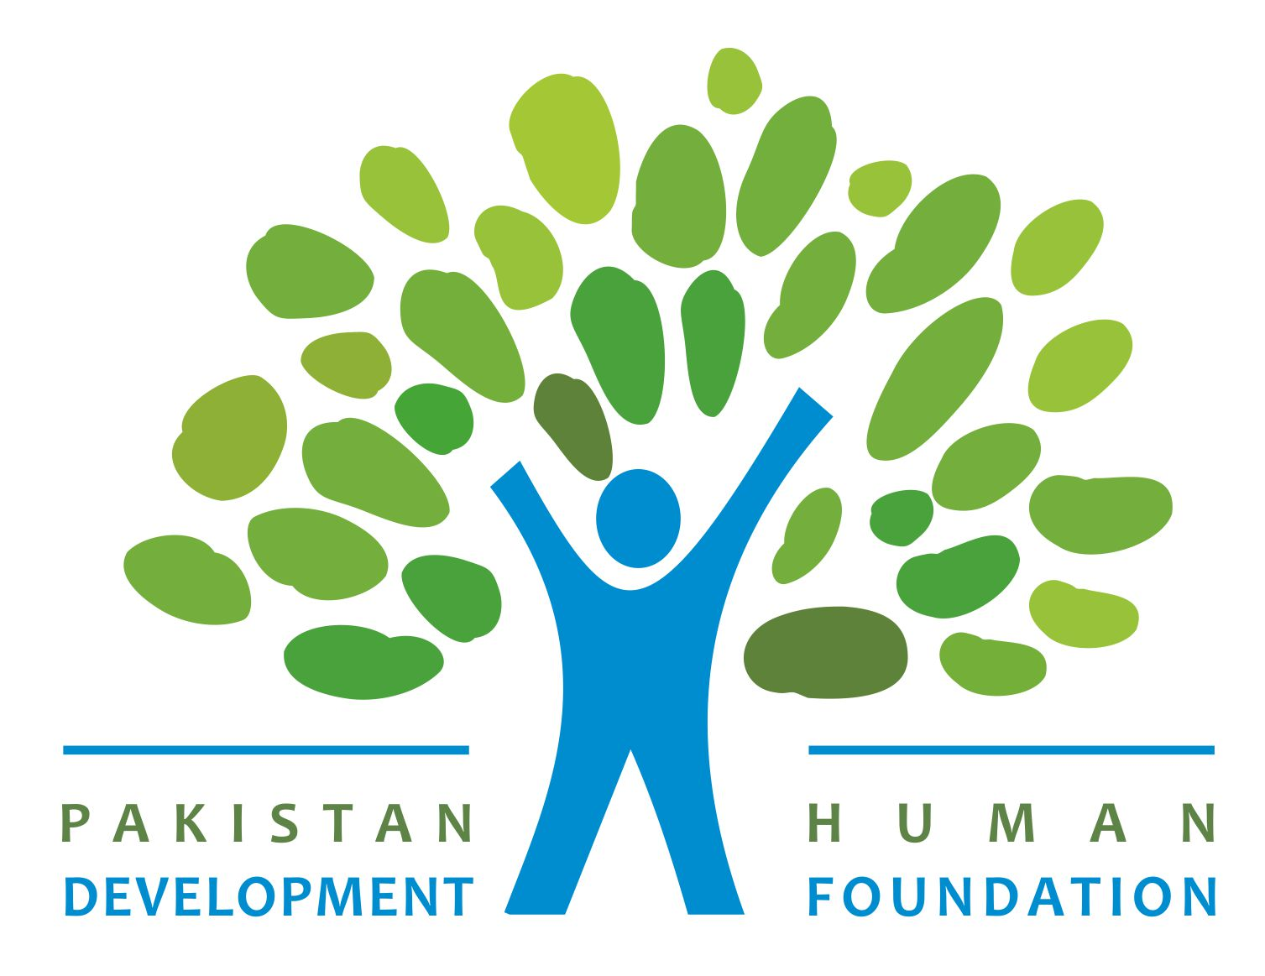
PHDF
Pakistan Human Development Foundation – Allahdin Group of Companies – a service to Pakistan’s Agriculture expanded and developed as an integral part of the Agriculture of Pakistan. The progress and prosperity have been the vision of AGC not only in corporal development but for the fulfillment of Corporate Social Responsibility to pave the way towards the development. AGC initiated its corporate social responsibility on the platform of Pakistan Human Development Foundation that took off for the journey of development and human rights in January 2005 through a dedicated group of development workers for women Empowerment, Children Development, Health, and rehabilitation of the oppressed groups of Pakistan.

PHDF successfully achieved lots of milestones in this learning journey by breaking the stereotypes and raising the unheard voices of vulnerable communities and individuals. We believe in synergies through partnerships with other organizations to institutionalized new thematic areas that lead us to pave the way for the vulnerable communities towards the development stream that includes disaster management, Peace & Harmony, rule of law, and youth development. The primary focus of PHDF remained the women and children who face miserable situations and lack necessities of life

Implementation of various communal and institutional initiatives with different Local, National, and International partners has opened new avenues of development not only for PHDF but for the associated stakeholders. The Research and Publications have been the core programs of PHDF that are being implemented since 2007 till date providing concrete facts and figures to the stakeholders at different levels.

Legal Name | Pakistan Human Development Foundation
Acronym | PHDF
Registered Under | Societies Registration Act 1860
Year of Registration | 2005
Registration Number | RM-22/S/2004-2005/
Registered under | Punjab Charities Act 2018
Registration Number: | 0506555026449998
FBR Registration(NTN): | 3952265-2
DUNS Number: | 645526547
NCAGE Number: | SGEQ9

Governance

The governance and Management structure of PHDF operates in a 3 tier structure which is:

- Board of Directors: BOD comprises seven members who lead the organization and holds autonomous status. The board members are elected for a period of 3 years. The Board Members voluntarily serve the purpose of community development utilizing their professional expertise to bring a positive change in society.

S# | Name | Position | Occupation
1 | Fahad ur Rehman | Chairman | Businessman/Social Worker
2 | Hina Dareshak | General Secretary | Women Entrepreneur
3 | Sher Muhammad Shaheen | Board Member | Private Job
4 | Sarwat Zahra | Board Member | Woman Entrepreneur
5 | Mehwish Zahra Naqvi | Board Member | Educationist
6 | Munir Akbar | Board Member | Landlord
7 | Abdul Hameed Abid | Board Member | Lawyer
8 | Moazamma Hussnain | Board Member | Lawyer and Social Activist

b) Management Committee – Three members Management Committee (MC) consists of Chairman, General Secretary, and Program Manager. The MC is responsible for human resources management, resource mobilization, and execution of projects and programs.

S# | Name | Position
1 | Fahad ur Rehman | Chairman
2 | Zahida Khan | Chief Executive Officer
3 | Saima Faiz | Programs Manager

Management Systems

- Human Resource Management
- Financial Management
- Research & Publication
- Program Management
Vision

“Socially and economically empowered communities and individuals striving for improvement in the quality of life through collective action and community activism where everyone has equal access to resources”
Mission

“Maximizing human, financial and community resources and empowering women through participatory approaches and long term interventions for sustainable development to benefit neglected and oppressed communities and make women play their role more effectively”

Policies

  - Human Resource Policy
  - Grievance Settlement Policy
  - Equal Opportunity & Affirmative Action Policy
  - Gender Policy
  - Financial Policy
  - Procurement Policy
Objectives

  - To empower the women by providing them the platform for their activism in economic and social development processes.
  - To contribute towards children's development and enable the children living in miserable situations to lead a dignified life.
  - To engage youth to facilitate mechanisms that promote tolerance, social harmony, and peace in society.
  - To provide health care services to the underserved and dispossessed communities for better health conditions; and increasing awareness on deadly diseases as HIV/AIDS, hepatitis, etc.
  - To enhance human and institutional development through integrated capacity building, training, research, and technical support to individuals and organizations.
  - To endeavor for poverty alleviation in the target areas through community-based development initiatives
  - To increase public understanding of climate change and disaster risk reduction.
  - To raise awareness about the importance of access to justice, human rights, and gender development.
Organizational Values

- Equal status and empowerment of women
- Children development as one of the core values
- Equity, inclusion, and respect for diversity and integrity regardless of religion, race, culture, class, creed, gender, and faith.
- Consideration for indigenous knowledge and wisdom.
- Well-being and dignity for all
- Excellence at par in executing community development endeavors

Strategies

- Awareness & Mobilization
- Research and Analysis
- Advocacy
- Linkages & Networking
- Social Inclusion
Approach

- Participatory
- Bottom-Up planning and execution
- Social Inclusion (gender-sensitive and minority inclusion)
- Reliance on local knowledge, conventional wisdom, and indigenous skills
Thematic Areas

- Youth Development
- Peace and Harmony
- Women Rights and Empowerment
- Disaster Management
- Child Rights
- Safe Charity
- Civic Rights
- Education
- Human Rights
- Health
- Charity & Donations
- Vocational Skills and Training
- Training and Development

Research & Publications

Pakistan Human Development Foundation publishes a fact sheet on Violence against Women “Sorrows of Women” since 2007 on annual basis to share the facts & figures with the stakeholders at all levels. It caters for the stats through desk research of more than 14 different types of Violence against women taking place in 36 Districts of Punjab. Newspapers, Police Stations, Hospitals, Local Networks are various sources of news of VAW.
Pakistan Human Development Foundation publishes a Quarterly Women Magazine “Sada-e-Nisa” to spread the unheard voices of women through their write ups on women rights and issue. Through Sada-e-Nisa, PHDF expects to create an enabling environment for the women to raise their voices and concerns to the masses. It is being published since 2007.

“Sorrows of Women”
“Sada-e-Nisa”

“A Fact Sheet on Child Sexual Abuse is an effort of PHDF since 2007 to raise the voices against the taboo of sexuality with children and adults (till age 17) which is going un-noticed and un-recorded due to our culture and legal constraints. PHDF through the desk research publishes a fact sheet with the incidents happening in 36 districts of Punjab to highlight this taboo to raise the awareness and concerns to the stakeholders at all levels. The publication of PHDF is a credible source for Child Rights Organizations, media and other stakeholders to devise policies, systems and mechanisms to ensure protection of young children.”

Geographical Coverage

- Multan
- Vehari
- Lodhran
- Muzaffargarh
- Khanewal
- Bahawalpur

Networking & Linkages

- Member Advisory committee of Industrial Home (Sanatzar Multan) Government of Punjab
- Executive Member Khanewal Chamber of Commerce and Industries Khanewal
- General Secretary – Rotary Club Chenab Multan
- Member Executive Council of Women Inner Wheel Club Multan
- Member Advisory board of Women Crisis Center Multan
- Member of price control committee, District Multan
- Established South Punjab Women Rights Network (SPWRN) in 2010 to address the issues related to women
- Member of Civil Society Network Multan
- Member of South Punjab NGOs Forum (SPNF)
- Tehsil Network Member with Trust for Voluntary Organization
Beneficiaries/Stakeholders Engagement Portfolio
- Member of Carvaan e Saqafat Network Multan

- District Government
- Women Jail
- Police
- Universities (Private & Public)
- Youth Groups
- Civil Society
- Marginalized / Disadvantaged Communities
- Disaster prone communities
- Industrialists
- Rotary Club
- Lions Club
- Human Rights Commission
- Paralegals

Ongoing Projects

Sr | Project Title & Description | Duration | Donor | Area | Beneficiaries
1 | Sada e Nisa  With the support of Allahdin Group of companies – A project to strengthen women engagement and empowerment through various awareness campaigns, publications and initiatives to pave the way for them to lead the way | 2007 to Date | Allahdin Group of Companies Multan | Jahanian, District Khanewal
2 | Health is Wealth  with the support of Aladdin Group of Companies– A project to provide free health services to the poor communities of Tehsil Jahanian, District Khanewal | 2005 to date | Allahdin Group of Companies Multan | Jahanian, District Khanewal | DB: 50000
3 | Clean & Green Jahanian  An initiative to create the awareness on climate change and to sensitize the communities on plantation of trees to help restore the damage to the climate change. | 2021 to date | Allahdin Group of Companies Multan | Jahanian, District Khanewal | DB: 200

Completed Projects

Sr | Project Title & Description | Duration | Donor/Organization | Area | Beneficiaries
1 | Aks e Aman  An initiative to strengthen the capacity of the youth of Southern Punjab Embroidery Industries Multan as the ambassadors of peace through various engagement tools and techniques for the promotion of peace and harmony in their institutes and communities | 7 Months | Development Alternatives Incorporated DAI | Multan | DB: 111  IDB: 2892
2 | Sorrows of Women  A program to capture violence against women by collecting the data of violence cases of Punjab with the support of Aladdin Group of Companies | 12 Years | Allahdin Group of Companies Multan | Punjab, Pakistan | DB: 9000
3 | Fact Sheet on Child Sexual Abuse  “A Fact Sheet on Child Sexual Abuse is an effort of PHDF since 2007 to raise the voices against the taboo of sexuality with children and adults (till age 17) which is going unnoticed and un-recorded due to our culture and legal constraints. PHDF through the desk research publishes a fact sheet with the incidents happening in 36 districts of Punjab to highlight this taboo to raise awareness and concerns to the stakeholders at all levels. The publication of PHDF is a credible source for Child Rights Organizations, media and other stakeholders to devise policies, systems, and mechanisms to ensure the protection of young children.” | 12 Years | Allahdin Group of Companies Multan | Punjab, Pakistan | DB: 3000
4 | Amn Kay Maimmar  An initiative to strengthen the capacity of the youth of Nawaz Shareef University of Agriculture Multan as the ambassadors through various engagement tools and techniques for the promotion of peace and harmony by strengthening the student societies | 9 Months | Development Alternatives Incorporated DAI | Multan | DB: 182  ID: 16000
5 | Sanatkar Amankar  A project to promote the message of safe charity and safe sacrifice among the industrialists and managers of different companies to save the misuse of charity and donations | 6 Months | Development Alternatives Incorporated DAI | Multan | DB: 500  IB: 10000
6 | Punjab Youth Workforce Development Program  PYWD – a vocational skill training initiative for the youth of Punjab to build the technical skills of the youth on Industrail traits to empower them economically | 6 Months | Louis Berger International | Multan | DB: 100
7 | Students’ Engagement for Learning & Leadership – SELL  An initiative to strengthen the capacity of the youth as ambassadors through various engagement tools and techniques for the promotion of peace and harmony | 19 Months | Development Alternatives Incorporated | Multan | DB: 500  IB: 4000
8 | Amn! Hum Se Hai  An initiative to Counter Violent Extremism in 15 Villages of 3 Union Councils of Tehsil Shujabad with the help of Village Peace Committees and Youth Peace Hubs | 7 Months | Development Alternatives Incorporated | 3 Union Councils of Tehsil Shujabad, District Multan | DB: 380  IB: 5000
9 | Radical to Active Citizenship  Strengthening Youth Associations for Rights-Based Initiatives and Rule of Law under the program Enhanced Democratic Accountability and Citizens Engagement under the supervision of College of Youth Activism and Development | 1 Year | College of Youth Activism and Development | District Multan | DB: 2000  IB: 10000
10 | Strengthening Youth for the promotion of peace and social harmony  An initiative of CYAAD under the grant of Foreign Common Wealth office UK to strengthen the youth for the promotion of peace and social harmony under the program Enhanced Democratic Accountability and Citizens Engagement. A project to inculcate the values of peace, tolerance, and social harmony and to equip the youth with conflict management strategies | 1 Year | College of Youth Activism and Development | District Multan | DB: 1000  IB: 10000
11 | Pur Aman Kisan, Pur Aman Pakistan  ” a project to build the capacity of farmers to be the ambassadors of peace by engaging them in constructive activities to promote the message of peace and to counter violent extremism by inculcating the values of peace, tolerance, and social harmony | 4 Months | Development Alternatives Incorporated – DAI | Districts Multan, Muzaffargarh & Lodhran | DB: 500  IB: 5000
12 | Discourage Gender-based Violence  with the support of UN Women - A project to stop violence against woman | 6 Months | UN-WOMEN | Districts Muzaffargarh, D.G Khan, Rajanpur | DB: 500  IB: 10000
13 | Situational Analysis on Conflicts and their resolution for social cohesion in District Muzaffargarh  with the support of South Asia Partnership Pakistan – A research project for the situational analysis to explore the ADR mechanism at the community level to find out social and economic effects of conflict on the lives of people as well as the find out the mechanism available at the Government level to resolve the conflicts | 4 Months | South Asia Partnership | District Muzaffargarh
14 | Life skills and theatre training of District Child Organizations  with the support of SYCOP– A project to build the capacity of 20 Children on theatre performances to sensitize people regarding child rights | 3 Months | SYCOP | District Muzaffargarh | DB: 1000
15 | Political Empowerment of Women  with the support of SPO– A project to create awareness among the women to participate in the electoral system | 6 Months | SPO | District Multan | DB: 3500
16 | Provision of Missing Facilities in Govt Schools  with the support of SPO – An advocacy campaign to increase the enrolment of girls in Schools and to activate the school management committees for the better functioning and provision of quality services to the students | 7 Months | SPO | District Multan | DB: 800
17 | Awareness Campaign on Human Rights & National/Local Social Issues  An initiative to create awareness among citizens on Human rights and national/local social issues | 2 Years | Allahdin Group of Companies | Districts Multan, Vehari | DB: 1000
18 | White Ribbon Campaign  PHDF implemented an initiative with the support of White ribbon Campaign for the eradication of violence against women | 2 Months | White Ribbon Campaign | District Multan | DB: 100  IDB: 500

TEAM

S# | Name | Position | Expertise | Qualification & Experience
1 | Ms. Zahida Khan | Chief Executive Officer | - Training & Facilitation  -Reproductive Health &  -Family Planning  -HIV/AIDS, Life Skills  -Gender, VAW  -Capacity Building, HRM  - Primary Health Care  -Peace and Religious Harmony  -Governance | MA Urdu, LLB, B.ed  Worked in different national NGOs & INGOs for the last 17 years.
2 | Ms. Saima Faiz | Program Manager | -Gender, VAW  -Project Management  -Reproductive Health  - Report and Proposal Writing  -Networking & Advocacy  Peace & Religious Harmony | MA Mass Communication  Worked in different national NGOs for the last 14 years.
3 | Zohaib Amjad | Program Specialist | Training & Facilitation  Networking & Advocacy  Program Development  Program Designing  Project Management  Team Building  Youth Development  Community Mobilization  Human Resource Development | MBA with 13 years of experience in the Corporate and Development Sector
4 | Sundas Farooq | Admin &  Finance Officer | Finance & Administration  Project Management  Team Building | MSc Economics with 5 years of experience in the Development Sector
5 | Muhammad Zeeshan Khan | Program officer | -Group Formation  -Event Management  -Assisting in Training  -Networking with partner organizations | MA Siraiki  Working in PHDF for last 7 years
6 | Huma Khan | Program Officer | - Research & Analysis  - Social Mobilization | LLB with 5 years of experience
7 | Adrish | Program Officer | Team building  Project Management  Community Mobilization  Youth Development | MSC Accounting & Finance with 4 years of experience in the development sector
8 | Waqar Hussain | Program officer | Community Mobilization  Youth Development  Coordination & Liaising  Logistics | MBA  With 10 years of experience in the field of corporate and development Sector

ORGANOGRAM

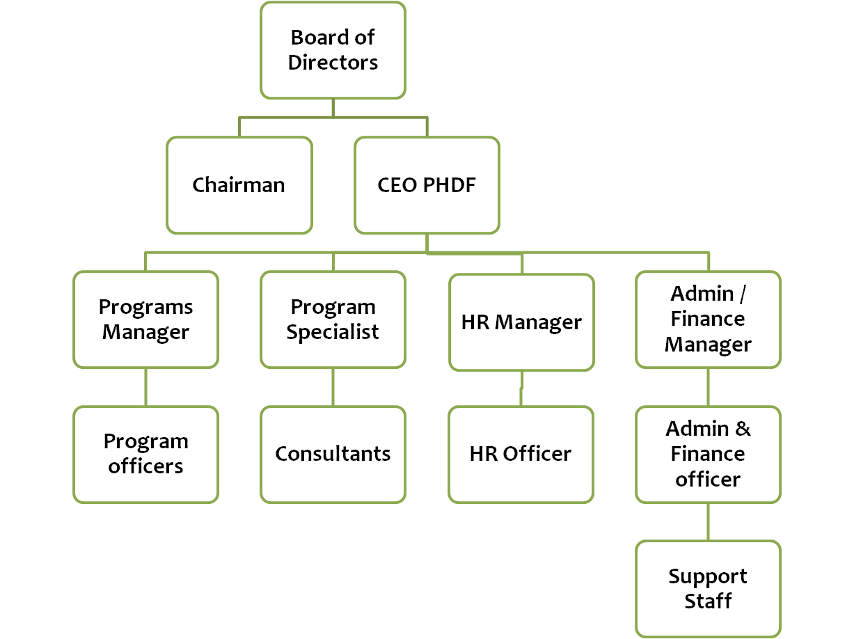

Explore & Connect with us

Email: | Phdf.org@hotmail.com
Facebook: | Facebook.com/phdf.org
Twitter: | @phdforg
Website: | www.phdfpakistan.com

